SSLTC Singles Box League 2024
Fun, social box leagues designed to help club members, new and old, integrate into the club and find other players of similar ability. Free to enter, the league and is open to 7-day members, aged 14 and over on 1st January 2024.
Round 2 of the summer leagues started on Monday 29th April 2024, with boxes reorganised every 4 weeks. This is a mixed Gents/Ladies competition for all abilities. Gents and Ladies may be drawn against each other and ladies receive a handicap unless they decline it.
Matches are best of 3 sets, tie-break at 6-6, with a 10-point tie break for a deciding set at 1-1. Promotion/relegation should give a good mix of opponents and allow players to find their level. With four players in a box, players need to arrange the 3 matches against the others in their box, over a 4-week period and enter the results on the LTA website.
We now use the LTA website to manage the box league, so members who want to enter will need an LTA number (sign up for PLAY membership https://www.lta.org.uk/advantage/) and set SSTLC as a venue on their profile.

To find our box league, use the LTA Competitions page https://competitions.lta.org.uk/, pick Box Leagues and search for Stony Stratford – or it should be at the bottom of your profile in Advantage. If you want more info, contact the organiser, Phil Gee on 07877 821256, pbgee@tinyworld.co.uk. From our box league page, there is an ENTER button.
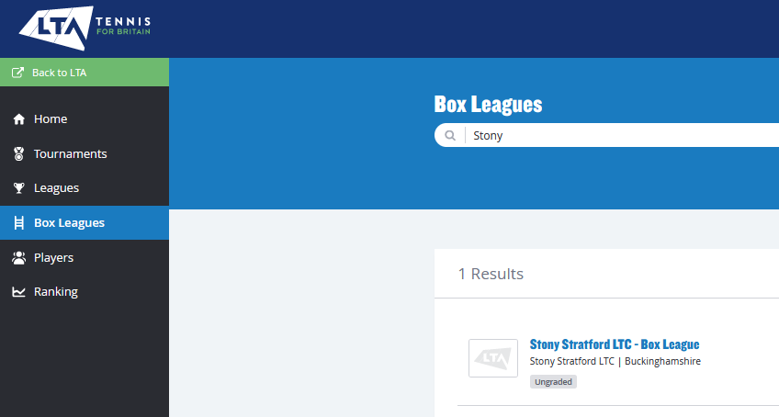
The first league was in May 2022, with 26 players and 6 boxes. In this current round, we have 45 players in 11 boxes. In 2 years, 99 players have registered and played in the box league.

