A HISTORY OF STONY STRATFORD LAWN TENNIS CLUB 1921 - 2013
AN ACCOUNT FROM ONE THAT HAS LIVED (MOST OF) IT

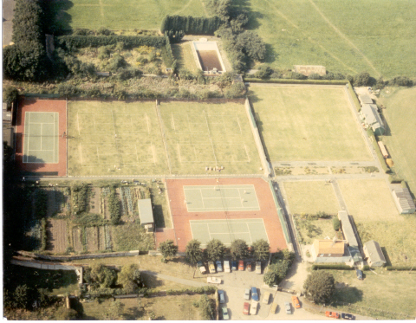
The Trustees acting for a local builder, a Mr. Ancell, purchased the ground in 1921. That year they had a shale court laid, and also in that year a railway carriage was purchased from Wolverton Carriage and Railway Works and delivered for the sum of five shillings to be used as a Pavilion. The Tennis Club was formed in 1923 and during that year four grass courts were laid. That makes it our 90 anniversary in 2013.
About 1935 two further grass courts were laid, but during the Second World War these were dug up to aid the 'Dig for Victory' campaign for extra food. Until the end of the War there were around 100 members. Membership was limited to those over the age of eighteen years. The Club played in the Bucks Shield leagues in 1946 and at the peak of playing success the Ladies reached Division One and the Gentlemen reached Division Two. In the late 1950s the Club declined in membership and closed down from 1961. In 1968 it was reformed and amalgamated with The Stony Stratford Town Club.
With new blood and enthusiasm the Club's future looked secure with a strong base from which to go forward. In 1978 the first new court was laid on what was the old ladies bowling green. This was of a 'Grey/Green' type court but unfortunately proved not to be a success. This economy type court was ripped up and replaced with a pair of all-weather courts in 1982. Both of these courts were fitted with floodlights and the old shale court converted to an all-weather court. An interesting aside was that finance for the floodlights was paid for by members and friends sponsoring an attempt to break the 'Guinness Book of Records non stop playing tennis match'. Unfortunately the four men playing just failed 72 hours of continuous tennis and consequently didn't make the record book, but we did get our floodlights! In 1983/1984 a further two all weather-courts were laid with a short tennis court for the juniors and a practice wall was completed thus utilising all available space. This provided four grass and five all-weather courts.
In 1986 the old railway carriage which had done sterling service as the Pavilion was upgraded with a second-hand Terrapin building with a veranda built. Several months later the rear of the Pavilion was landscaped as a family barbecue area. Decorative lighting was fitted around the building and extending roller blinds were fitted to the front to cover the veranda.
In 1987 the Club then embarked on its most ambitious project to-date, replacing the four grass courts and one all-weather court with Omnisport synthetic grass all-weather surfaces. The latest in floodlights were also fitted to thus giving the Club three floodlit courts. This project, costing £60,000 was completed and the development was opened by the then Mayor of Milton Keynes, Tom Branson. Most of the finance was raised from Club funds and from within the Club by way of loans, but financial assistance was also received from the Borough of Milton Keynes, Milton Keynes Development Corporation, The Lawn Tennis Association (LTA) and The Buckinghamshire LTA. In 1990 Judy Angus joined the Club as the Club Professional which was a step towards cementing a relationship to take us into the future. In 1991 was the installation of a sprinkler system to irrigate the synthetic surfaces. 1992 was the year the grandstand was erected and in 1993 the floodlights on Courts 6 and 7 were upgraded to 'Metal halide'.
Since then we have been working and planning towards our 'Millennium Project'. A purpose built Pavilion, new floodlights on seven of the Courts, resurfacing the majority of our court surfaces and installing purpose made junior facilities. Our existing Terrapin building did not have planning permission sixteen years ago, but on appeal the planning committee came to the site and relented on the understanding that a permanent replacement in the future would comply with normal regulations and be conducive to a conservation area. In 2001 Phase 1 of the Millennium project was completed at a cost of just under £150,000. Courts 1-5 were completely rebuilt and laid with synthetic sand filled grass and state of the art floodlights added to Courts 2-5 with the existing lights on Court 1 upgraded to suit. Club funds were assisted by Sport England and the LTA.
November 2002 saw the resurfacing of Courts 8 & 9 with lines in accordance with LTA’s Performance Club requirements. Club funds of £18,000 paid for this as we did not have sufficient time to appeal for assistance. Further proof that the Club is moving in the right direction came with the grant of £500 made at the Club's 2002 AGM by Lynne Moxon, LTA County Development Office together with accreditation as a Bucks LTA Performance Club.
Thank you to John Taylor for this account of our history.
Footnote: Since this was originally written in 2002, the club has continued to grow rapidly and our facilities have improved immeasurably. We moved out of the Terrapin clubhouse in June 2006 into a fantastic new clubhouse located in the centre of the club’s grounds. The old clubhouse still stands next to Court 1 and in time will be renovated to create a wet weather training and club storage area. Furthermore Courts 6 & 7 have been resurfaced with sand filled grass. Not wishing to stand-still the Committee are continually looking to the next project to enhance the facilities and membership value. Planning permission has now been granted to cover and floodlight courts 8 & 9 and the club is investigating their re-surfacing to artificial clay. Something to get our teeth into for the winter of 2013-4!

